Project Design Phase - Problem - Solution Fit Template
Date | 11 August 2026
Team ID | N/A
Author / Team Member | Aditya Kamble
Project Name | ShopEZ Ecommerce Application
Maximum Marks | 2 Marks

Author: Aditya Kamble
The Problem-Solution Fit analysis ensures that each identified friction point for e-commerce customers, sellers, and administrators is addressed with a direct, validated technical capability in the ShopEZ application.
Customer Problem & Solution Canvas Diagram:

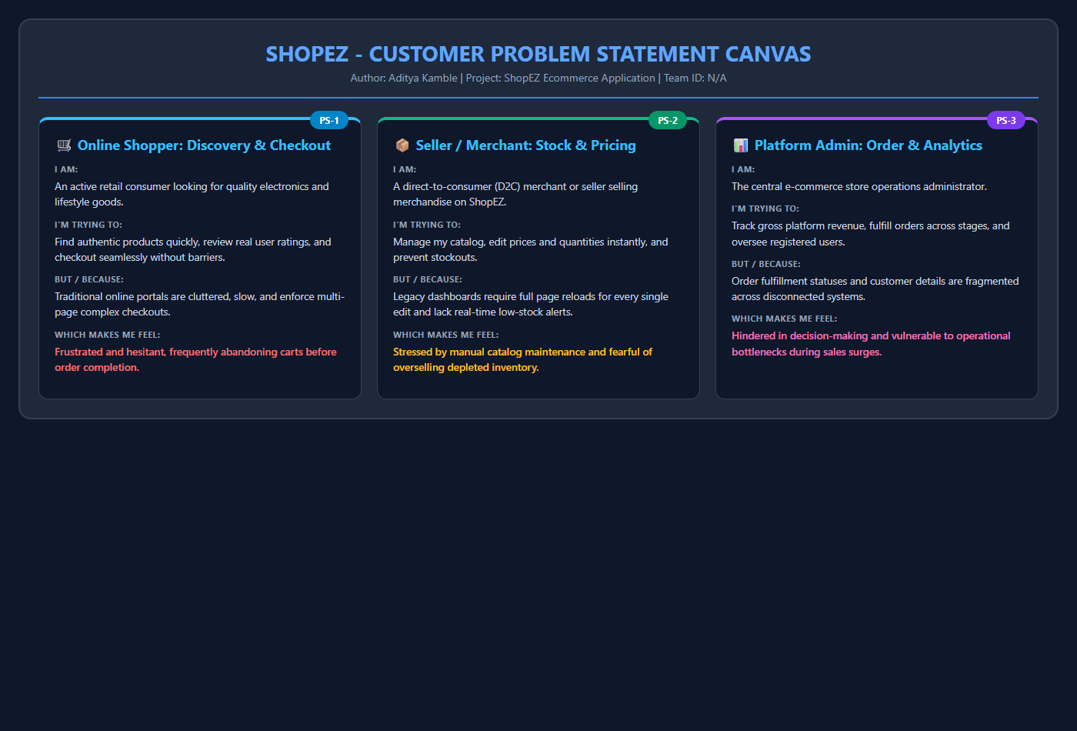
Figure 6: Problem-Solution Fit Alignment Diagram

Identified Problem | Root Cause | ShopEZ Technical Solution | Validation Metric
High cart abandonment due to complex checkout | Multi-step redirects and mandatory unnecessary fields | Single-screen streamlined checkout with auto-filled profile address and COD default | 100% test completion of checkout flow in < 30s
Customer uncertainty regarding stock availability | Outdated catalog inventory and opaque fulfillment stages | Real-time stock deduction upon order creation, low-stock warnings, and transparent status tracking | Clear status indicators visible on user profile and seller view
Seller fatigue managing prices and stock across multiple pages | Clunky traditional admin portals requiring page reload per product edit | Seller Central (`/admin/sell`) with inline editable table cells triggering asynchronous PUT requests | Zero page reloads required to modify prices and quantities
Unorganized product discovery across merchandise | Poor category taxonomy and slow server-rendered search queries | Fast client-side routing with instant category tabs (Electronics, Fashion, Home) and regex MongoDB search | Search and filter query execution in < 150ms

